Online Sales analysis:

1. Plot of Profit and Sales amount against product category and calendar year as a global filter.

Note:

There are 3 types of dimension hierarchy: Product hierarchy, Geography and Time.

Measures are fact tables: FactOnlineSales, FactInventory and FactSales.

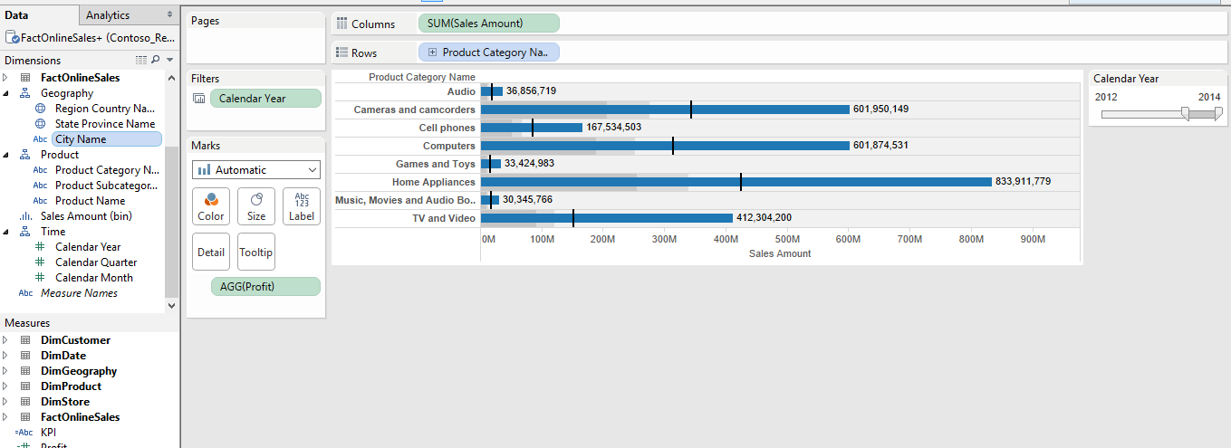

1. Cumulative histogram for the sales amount:

Sales amount varies and this gives the probability distribution of values found in the DB. According to the graph most of the sales amount is in the range of 0 to 234$.

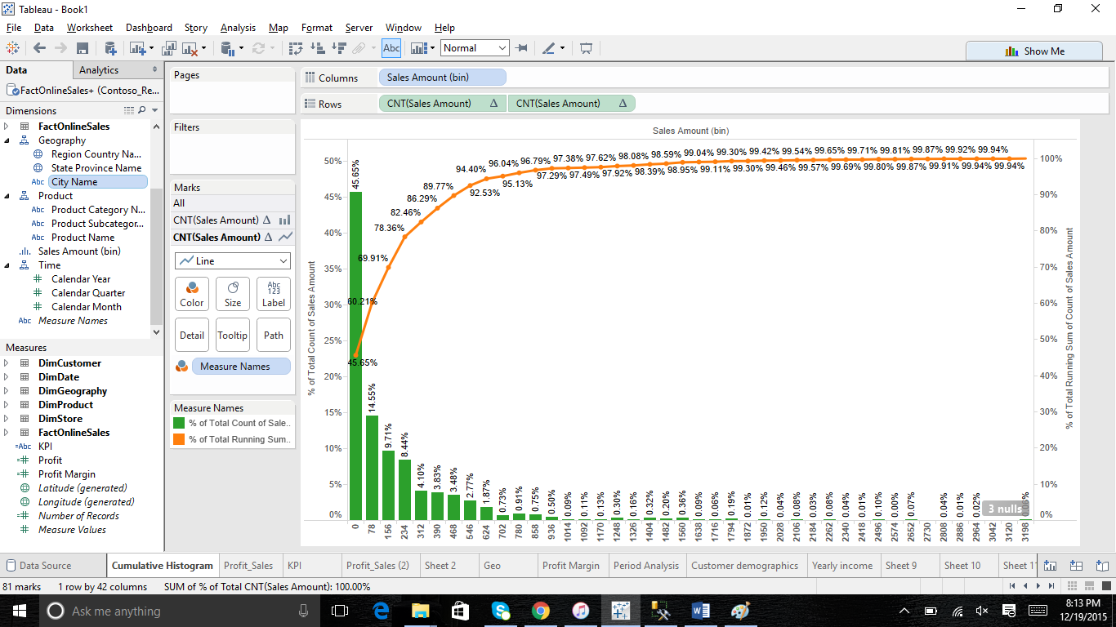

1. **KPI chart:** The average is taken and those above average are ‘above benchmark’.

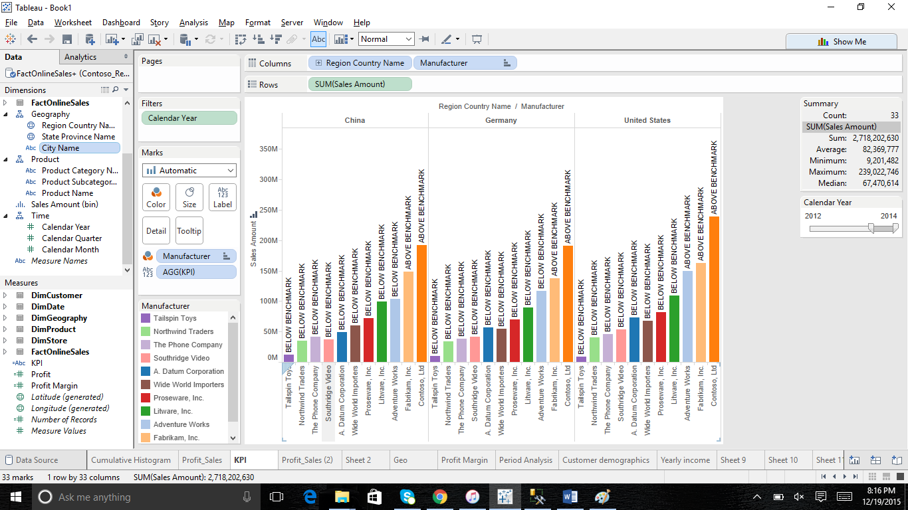

1. Profit and Sales amount by calendar year:

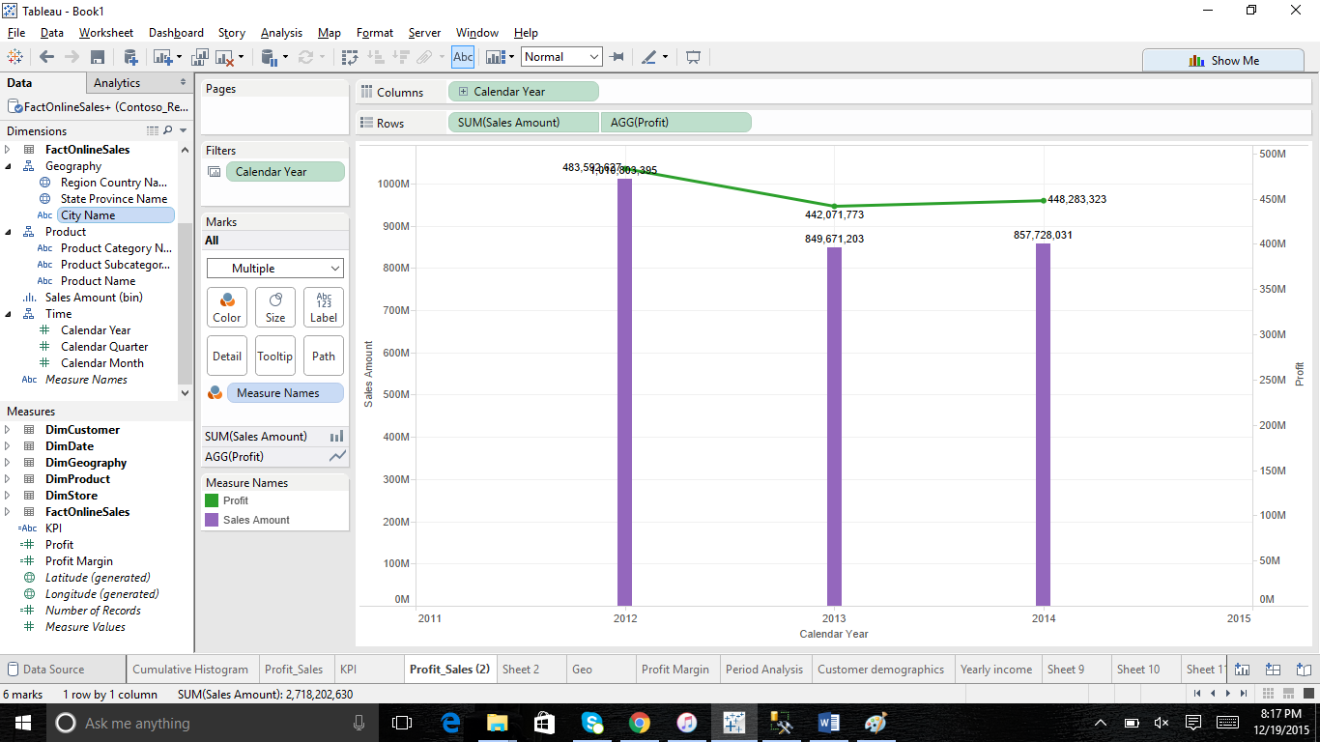

1. Geo map showing regions with maximum sales amount.

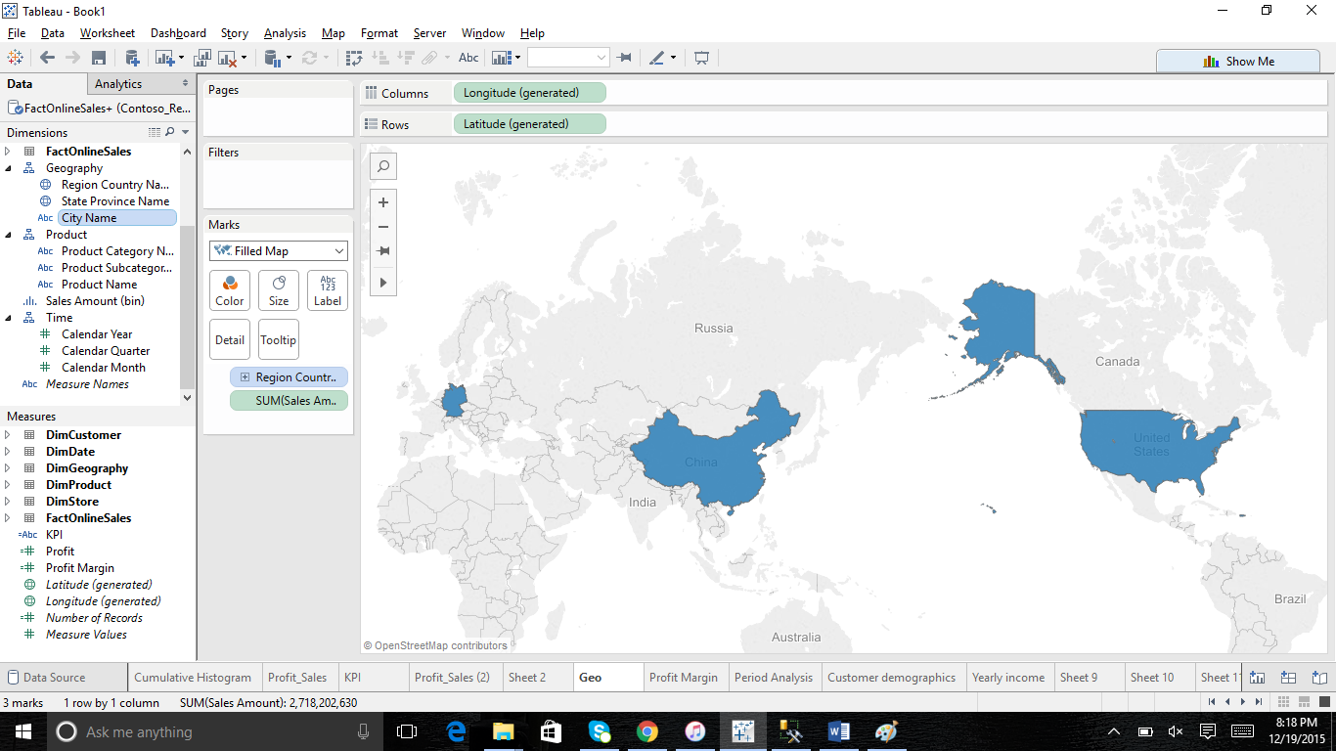

1. Profit margin against product category.

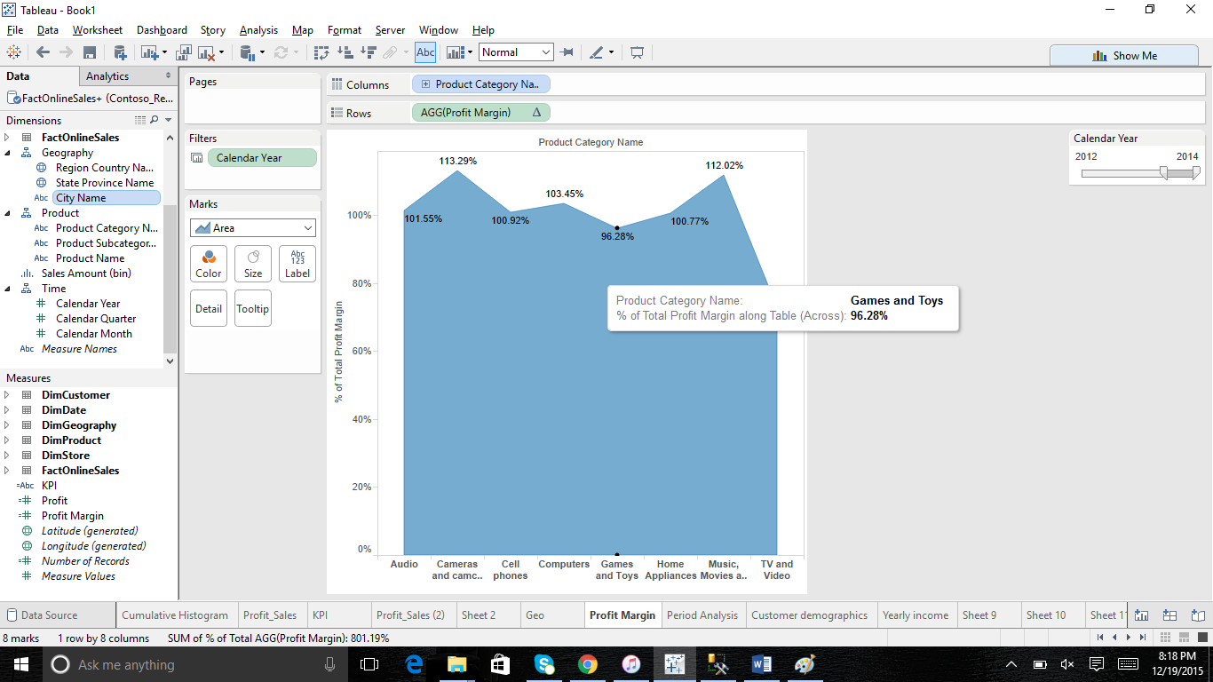

1. Period analysis: Sum of Sales amount and aggregate of profit.

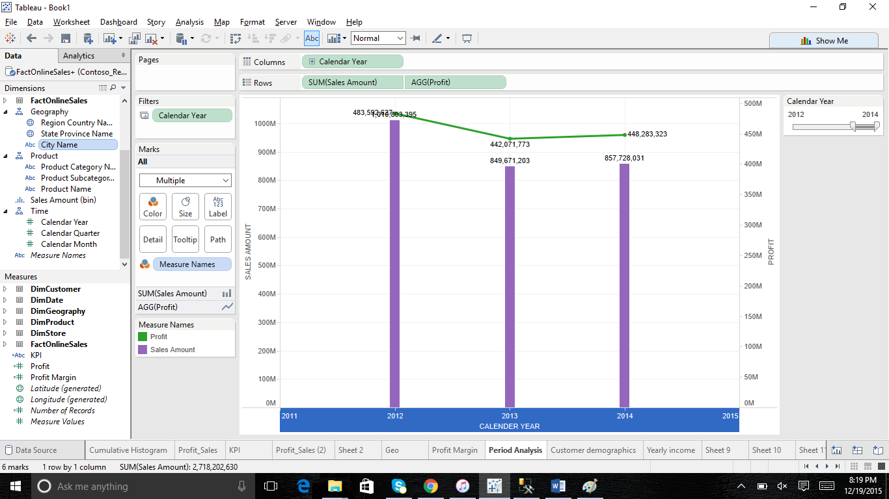

1. Customer Demographics: Profit and sales amount against education and calendar year

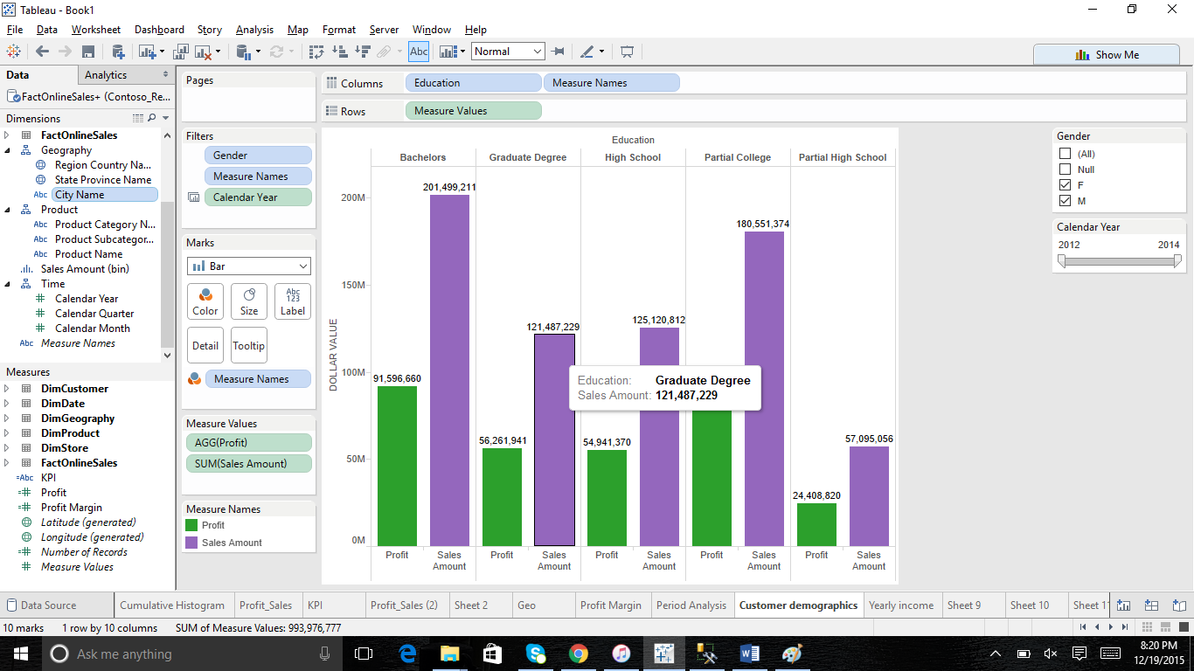

1. *Cumulative histogram: This is an advanced analytics chart showing the varying values of the unit cost. As per the chart 0 to 40$ has maximum values in the retail database. The line graph shows the added values of total running sum.*

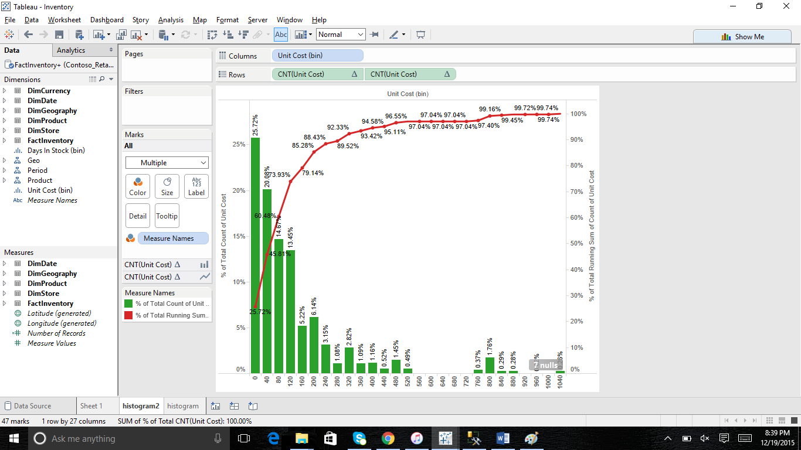

1. The dashboard shows online sales analysis with the global filter as calendar year. The dashboard consists profit margin, period analysis, customer demographics and KPI.

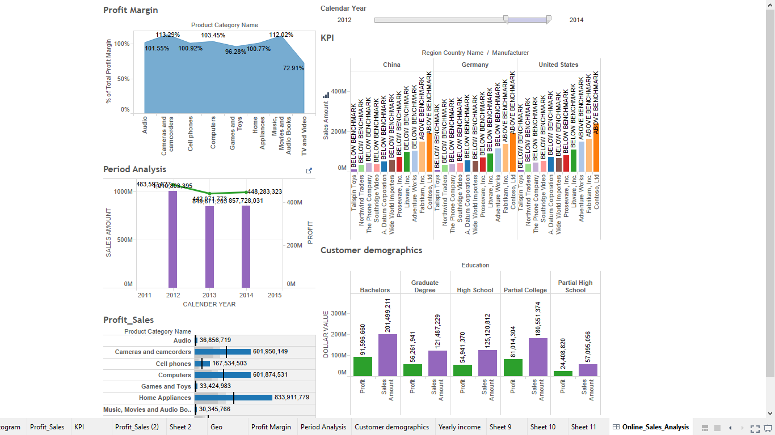

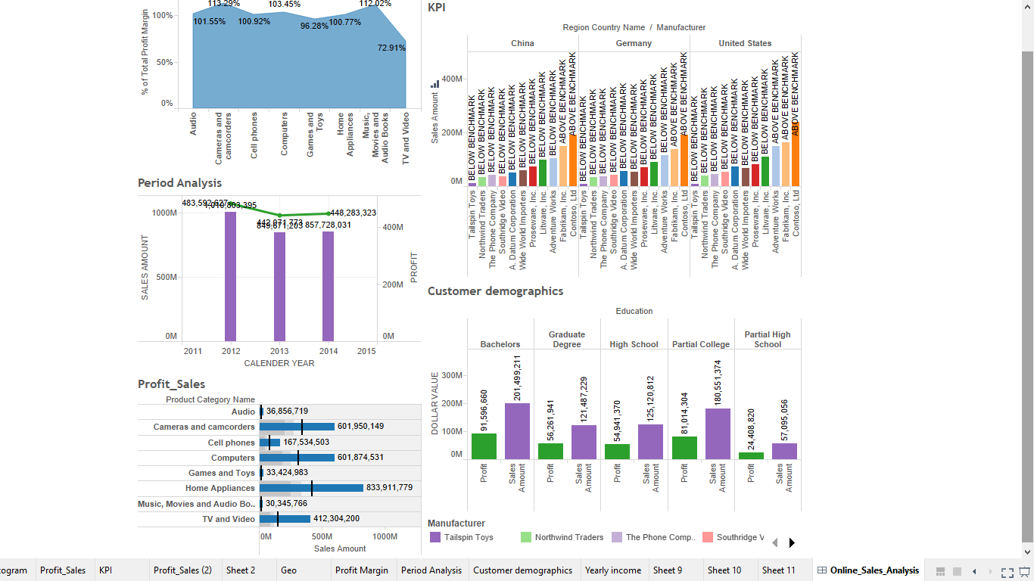

Store sales analysis:

1. Dashboard showing store sales amount, Heat map, Profit and rank of sales amount for the outlets at different locations:

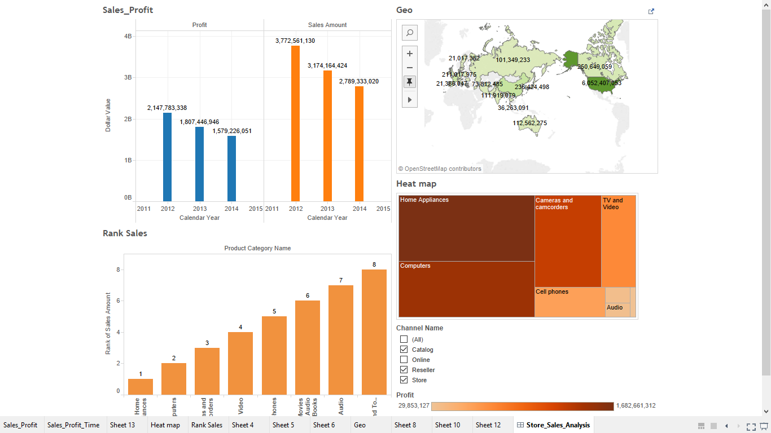

1. Profit and sales against channel name:

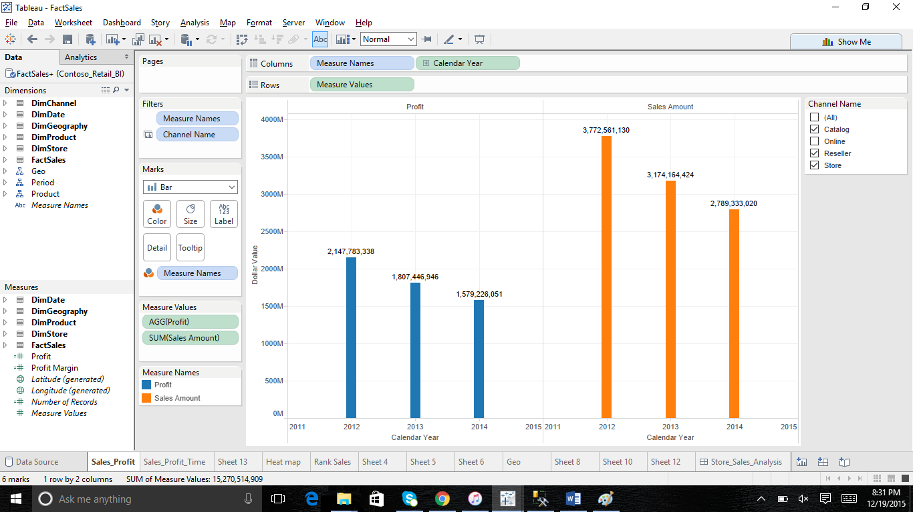

1. Sales and profit against calendar year and filter as channel name:

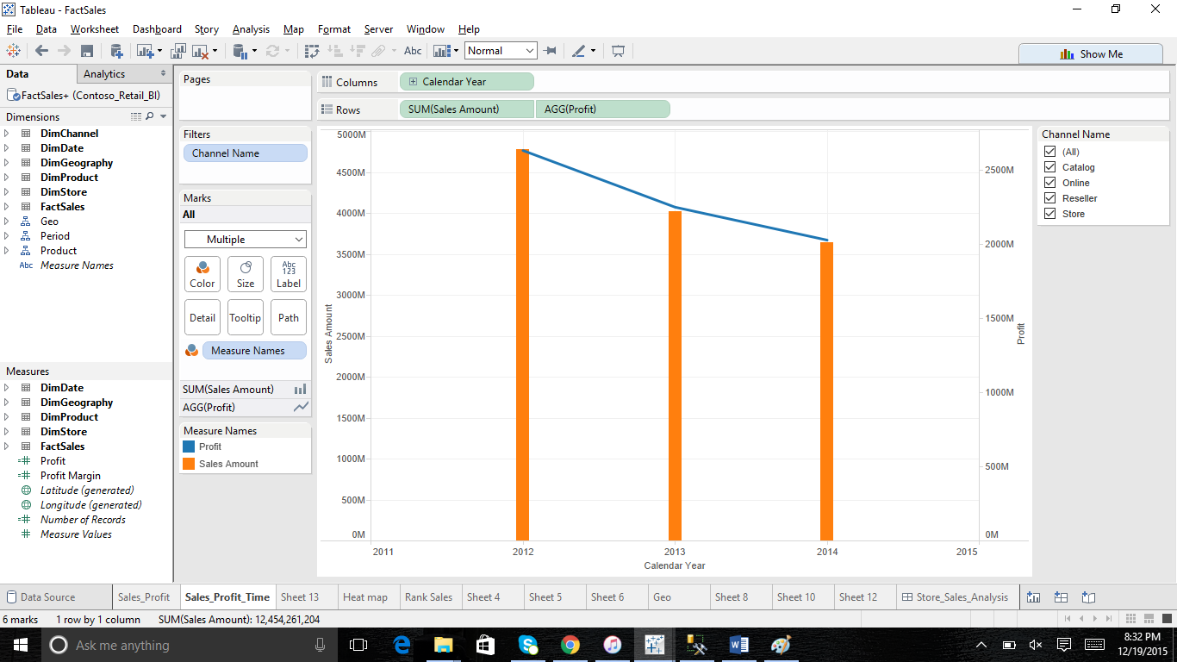

1. Heat map showing sales amount and profit against channel name:

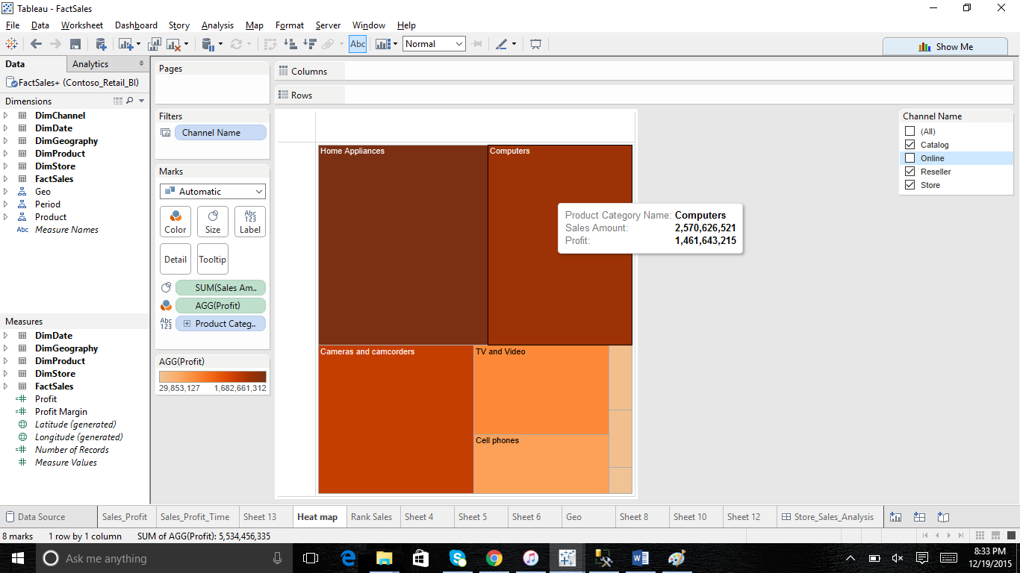

1. Ranking sales amount against product hierarchy and region, channel.

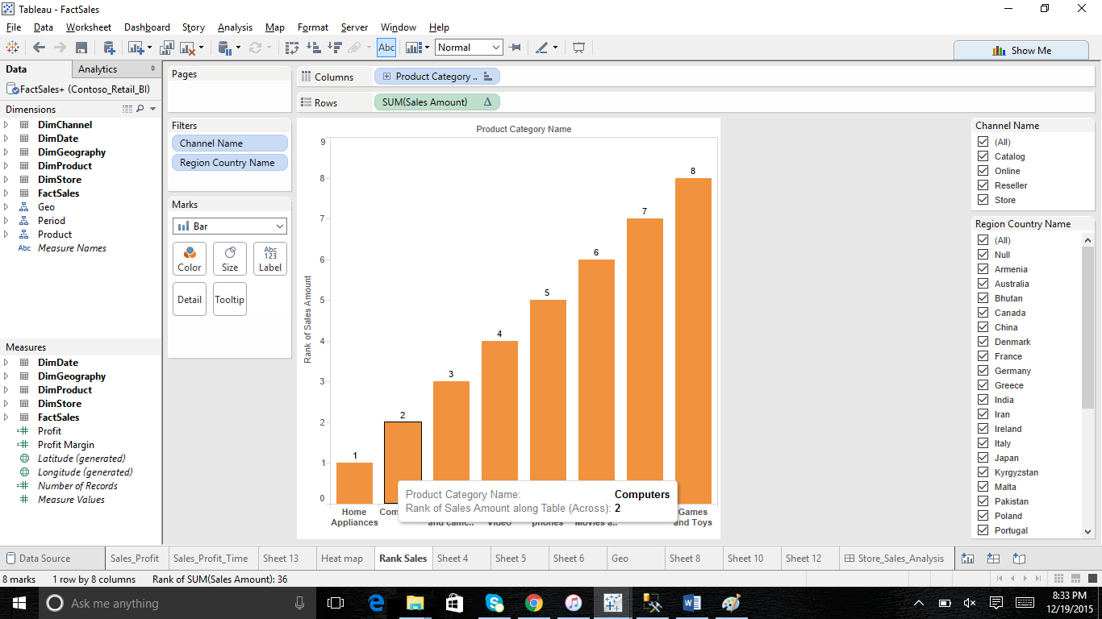

1. Geo map showing the sales amount with filter as channel name.

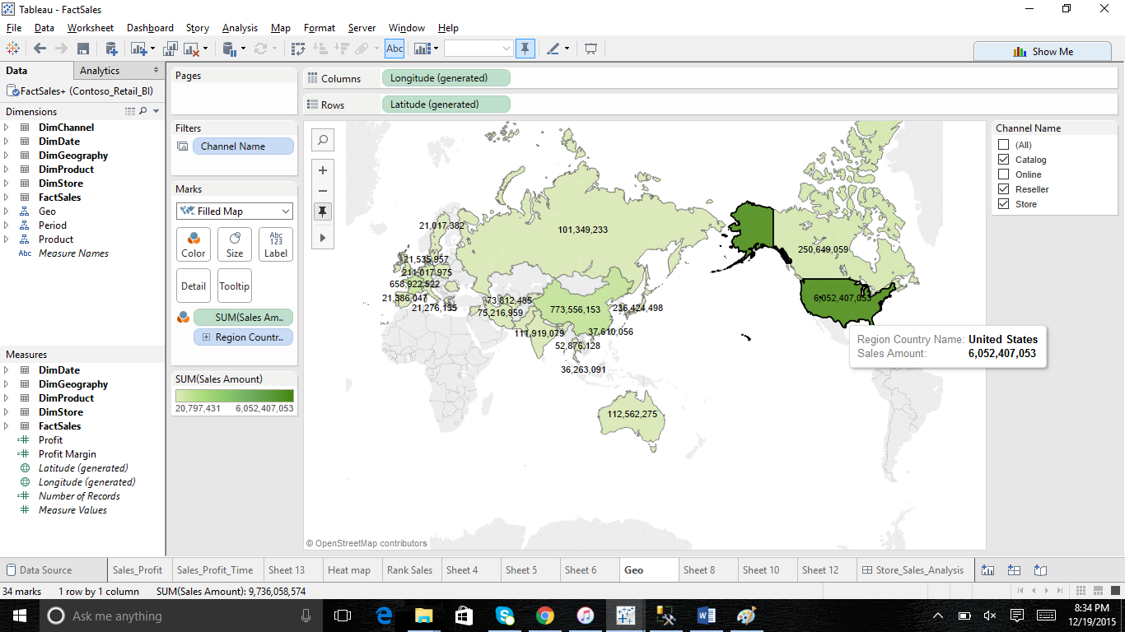

Inventory analysis:

1. On order quantity against region country name against calendar year.

